Graph Exercises

1 a. How many 1's are there in the adjacency matrix that represents the directed graph?
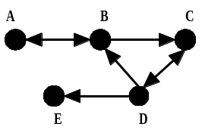

1b. Write the adjacency matrix and the reachability matrix.

1c. (Optional) Choose an appropriate graph data structure. Create the input file. Create the driver class. Run the program and confirm your answers above.

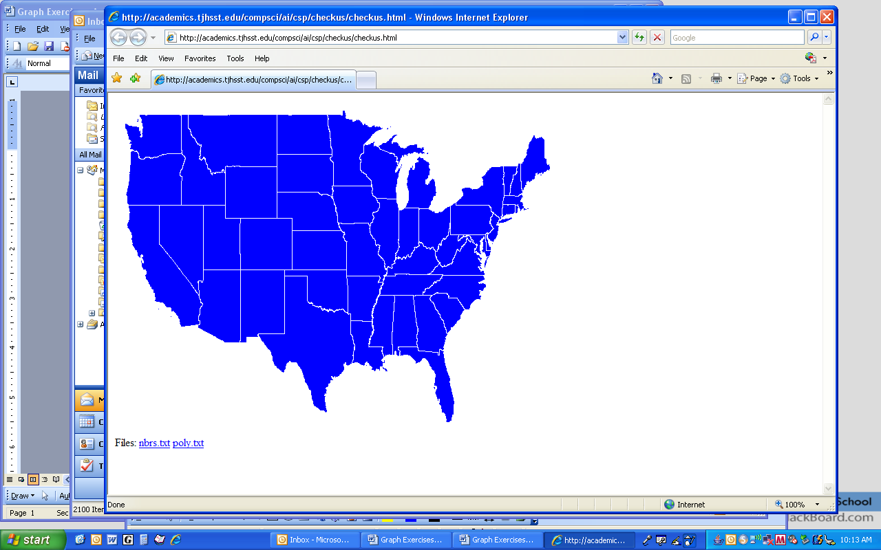
2. Consider the map of the six New England states, ME, NH, VT, MA, RI, and CT.
2a. Draw a graph that shows the neighbors of each state.
2b. Write an adjacency list for the neighbors of each state.

2c. (Optional) Choose an appropriate graph data structure. Create the input file. Create the driver class. Run the program and answer these questions:
Is ME reachable from VT? ________
Is VT reachable from RI? ________
Is CT reachable from ME? ________
Is this graph connected? ________

3. Consider the following directed graph. You should assume that all lists of adjacent vertices are in alphabetical order.
C

A
E
S

D
B

3a. Show the breadth-first search tree with S as the source.

3b. Show the DFS search tree for all vertices with S as the source.

3c. (Optional) Choose an appropriate graph data structure, write an input file, and check your answers above.

4. In the graph below, each vertex represents an island and each edge would be the cost (in millions of dollars) to build a bridge to connect those two islands via a road. You must find a way to build bridges so that one can drive between any two islands with the goal of minimizing the construction cost.
a
b
e

d
f

c
g

4a. State the name of the algorithm you will use to solve this problem. ______________

4b. (Optional) Choose an appropriate graph data structure, write an input file, and check your answer above.

